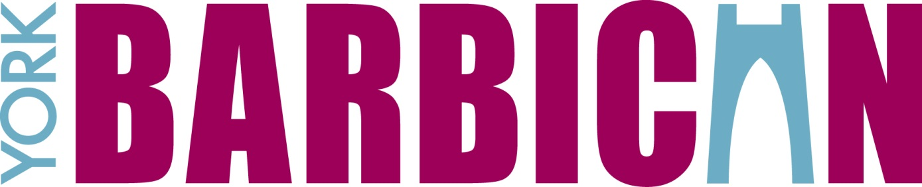

TECHNICAL SPECIFICATIONS

# Stage

The York Barbican stage is made up of 6 rows of 7 off 8’ x 4’ steeldeck, with a row of custom decks behind these cut into the shape of the back wall and a row of 5 off 8’ x 4’ steeldecks in front, with a custom deck each end shaped to cut the corners backwards. There are wings provided using 2 rows of 2 off 8’ x 4’ decks each side upstage. There are 5 trusses above the stage.



Standard stage measurements are:

Stage Width is 56ft (17.06m)

Stage Depth (maximum) is 28ft (8.53m)

Stage Depth (minimum) is 24ft (7.32m)

Stage Height (from auditorium) is 1m

Working height to trusses (maximum) is 10m from a 1m stage height

There is a midstage bridge in the grid, restricting height to 9.5m above stage

Height to grid is 11.14m from a 1m stage height

Height to points is 14.05m from floor or 13.05m from stage

[Stage contd]

Access doors at the side of the stage - height is 2.03m, width is 1.86m

Rear stage access (up a ramp) – height is 2.365m, width is 4m

Shutter from dock (‘Sports Hall’) to stage – height is 3m, width is 6m

Shutter from car park to dock – height is 4.45m, width is 3.45m

Stage Door car park measurements – 12m x 13.4m

We provide parking at Stage Door and there is a Q-Park car park across the road from there. Please advise York Barbican of your parking requirements and we will do our best to honour them.

We can also allow parking at Stage Door on non-show days at a charge of £50 per truck or £100 per bus (electricity included).

There is no fly tower.

There are 5 x trusses over stage (SWL = 750kg each, evenly distributed) with motors and controller.

Distances from front of stage are:

Truss 1: -230mm (truss 1 cannot be moved when PA is in place)

Truss 2: +1045mm

Truss 3: +2600mm

Truss 4: +6100mm

Truss 5: +7400mm

Front of house rigging position (no house truss, just points): -1600mm

Extra trusses can be rigged from our points, subject to use of a suitably qualified rigger (we can supply).

The stage surface is black birch plywood.

The auditorium floor surface is grey xxx.

The stage can be extended using hired (and recharged) decking. The maximum dimensions of the stage are 88ft (max) x 36ft (max), with less width on the front 2 rows. This can accommodate a choir of up to 735. There is a charge to build and dismantle the extra staging.

Also available:

|  |  |
| --- | --- |
| 8’ x 5’ Steeldeck (for drum risers etc.) | 7 |
| Stage weights | 6 |
| Black legs | 8 pr |
| Black tabs (not full width) | 1 pr |
| Green tabs (not full width) | 1 pr |
| Marley dance floor 1.5m x 17m (rechargeable) | 6 + 2 custom cuts |
| Music stands (with lights) | 15 |
| Music stands (without lights) | 30 |
| Conductor’s stand | 1 |
| Orchestra chairs (green) | 60 |
| Steinway Model B grand piano | 1 |
| Steinway Model D grand piano | 1 |
| CCTV monitor for prompt corner | 1 |
| Cue lights | 7 |

# Dressing Rooms

1 principal dressing room for up to 3

2 principal dressing rooms for up to 2

1 larger dressing room for up to 25

Our Toft Room can be used for catering or as another dressing room for up to 30.

All the above rooms have WiFi, toilets and showers.

We can provide hand towels and bath towels (recharged).

# Auditorium

The auditorium can be used as either fully seated or standing in the stalls plus seated in balcony. For sporting events and conferences we can use flat floor in the stalls only.

Retractable seating can be removed to create a large standing/exhibition area suitable for standing gigs, conferences, exhibitions, sporting events, in-the-round performances and a host of other uses.

Maximum attendees are as follows:

Fully seated (no kills) – 1466

Fully seated (with standard kills) – 1328

Seated without AA & BB (extra rows at front) but with kills - 1280

Standing in stalls, seated in balcony – 1850

Just standing (sports & conference only) – 1281

Cabaret style in auditorium – 400

Maximum seats in balcony – 545

Maximum seats in stalls – 923

Maximum wheelchair spaces - 16

Other layouts are available; please enquire at the Barbican

**Distances from the front of the stage** are as follows

(where x = along the floor; y = height above floor level):

To mixing position (seated audience): x = 14,950; y = 5,800

To mixing position (standing audience): x = 13,000; y = 0

To back row of balcony seating: x = 24,150; y = 11,000

To back of stalls when balcony not in use:

x = 14,950; y (if tiered seating in use) = 4,300

Height to bottom of house PA: xxx

Distance from front of stage to house PA motor line: 480mm

# Lighting

There are 150 circuits of Zero 88 Chilli dimmers: 138 @ 2.5kW + 12 @ 5kW. Our lighting board (rechargeable) is a ChamSys MagicQ40N desk with two Extra Wings (12 extra faders each + 12 extra buttons each).

There is a permanent FOH rig of 10 x Selecon SPX 15/32 profiles (800w) on Bridge 1 and 10 x Teatro Acuto 19/32 profiles (2kW) on Bridge 2. There are 2 x 6-way bars of Par 64s c/w CP62 on FOH providing a 3 colour wash of Red, Blue and Amber.

Also available for use onstage are:

|  |  |
| --- | --- |
| 6-way bars with Par 64s c/w CP62 | 8 |
| Par 64s on floor bases | 8 |
| Par 64 (singles) | 22 |
| Spotlight Combi fresnels 1.2Kw | 16 |
| Robert Juliat PC 1.2 kW | 8 |
| Coemar Passo 2000 1kW fresnels | 14 |
| Robert Juliat 614 profiles 15/38 | 6 |
| Lee Colortran 1kW asymmetric flood | 16 |
| Strand Coda 1000 flood | 4 |
| Grelco (15A – 2 x 15A) | 10 |
| Socapex (inc plug and socket tails) | 10 |

We do not have moving lights as part of the house rig, but can sub-hire these for you if required. Please contact our Technical Manager for a quote.

There are 2 x Pani 1200 follow spots FOH, either side of the control room (rechargeable).

Houselights are on DMX channels 501 - 506

# Sound

The York Barbican has an in-house PA system which can be rigged or de-rigged as required. It consists of an HK Compact Cohedra flown line array system of 2 x HK CDR210 subs per side plus 8 x HK CDR108 Mid/High boxes per side plus 2 x HK CDR210 subs under the stage each side. There are also 4 x CT108 front fills available for use if rows AA and BB are in use. There is also 1 x CT108 each side to fill in the slips (side seating). These are all run from Firnet controllers and Lab Gruppen amps.

Our line array is flown on 1 x Liftket 500kG double brake motor per side (L&R).

Our desk is a Yamaha LS9-32 (rechargeable).

Mixing position for seated events is in the front row of our balcony. A space 6m x 1.2m is available, with the row behind killed from sale for sighlines.

Mixing position for standing events is at the rear of the auditorium floor. A space 7m x 3m is available. Please let us know if you need more space.

Also available for use are:

|  |  |
| --- | --- |
| Shure SM58 | 2 |
| Shure Beta 57 | 4 |
| AKG SE300B lectern mic | 2 |
| K&M mic stands | 8 |
| XLR Mic leads | Up to 30 |
| Denon DN-C620 CD player | 1 |
| EMO single DI boxes | 4 |
| EMO double DI box | 1 |
| Jack – Jack leads (¼”) | 6 |
| Comms packs c/w headset | 5 + 1 @ prompt desk |

Multicore route is along the front of the stage to centre, under the seating unit and up onto the mix position (50m multicore will be perfect).

Multicore route for standing gigs is up into grid, along the grid and down to mix position (50m multicore will be fine).

We have a Sennheiser infra-red hard-of-hearing system.

We have a FOH and backstage calls system, run from Prompt Corner. FOH calls are operated by house staff.

# Power

Power SL is provided as 1 off 63A 3-phase supply. We have a 63A 3-phase to 63A 1-phase converter available.

Distance from this power supply to monitor desk is ≤20m.

Power SR is provided as 3 off 125A 3-phase, 1 off 32A 3-phase or 1 set of 400APowerlocks.

Distance from this power supply to dimmer world is ≤20m.

13A sockets are available throughout the building.

Catering power is split from a 63A 3-phase supply into 32A, 16A and 13A single phase outlets.

Bus power is available as 1 x 32A and 2 x 16A single phase feeds, plus 1 x 32A three phase socket. Please email for the code to the number padlock that protects the hatch.

**York Barbican**

Other rooms and spaces are available for use within the York Barbican.

The ***Fishergate*** Room can be used for smaller performances (max 120),as well as being a restaurant space or a function room (it has a built in screen and projector). There are 4 x LED Pars (2 x RGB, 2 x White) lighting a small temporary stage and a small PA system suitable for the room. Perfect for comedy!

Our ***Lendal*** Suite can be used as 2 separate rooms or as 1 combined room.

***Cliffords*** can be used as a VIP bar, a small restaurant space or a break-out room.

Our ***Sports Hall*** is a large room which can be used as a dock area, an exhibition hall or a large dressing room/green room amongst many other possible uses.

Maximum attendees are as follows:

|  |  |  |  |  |  |  |
| --- | --- | --- | --- | --- | --- | --- |
|  | Room Size  (sqm) | Theatre | Boardroom | U-Shape | Cabaret | Standing |
| Main auditorium |  | 1466 | n/a | n/a | 400 | n/a |
| Stage area | 292 | n/a | n/a | n/a | 100 | 375 |
| Seating area | 490 | 1400 | n/a | n/a | 350 | 1000 |
| Floor area (no stage) | 782 | 1500 | n/a | n/a | 400 | 1800 |
| Ground floor foyer | 420 | 120 | 42 | 38 | 100 | 500 |
| First floor foyer | 218 | 60 | 28 | 26 | 50 | 250 |
| Fishergate | 120 | 100 | 28 | 24 | 60 | 185 |
| Cliffords | 80 | 30 | 15 | 10 | 50 | 100 |
| Lendal 1 | 50 | 40 | 20 | 18 | 20 | 40 |
| Lendal 2 | 43 | 35 | 20 | 18 | 20 | 40 |
| Lendal combined | 93 | 70 | 32 | 26 | 40 | 75 |
| Toft 1 | 30 | 30 | 16 | 14 | 12 | 30 |
| Toft 2 | 40 | 30 | 20 | 16 | 20 | 30 |
| Toft combined | 70 | 55 | 30 | 20 | 30 | 60 |
| Sports Hall | 420 | 736 | n/a | n/a | 320 | 800 |

We have a merchandise area FOH measuring up to 5m x 2m. Commission is charged on all merchandise sales.

## Building plan

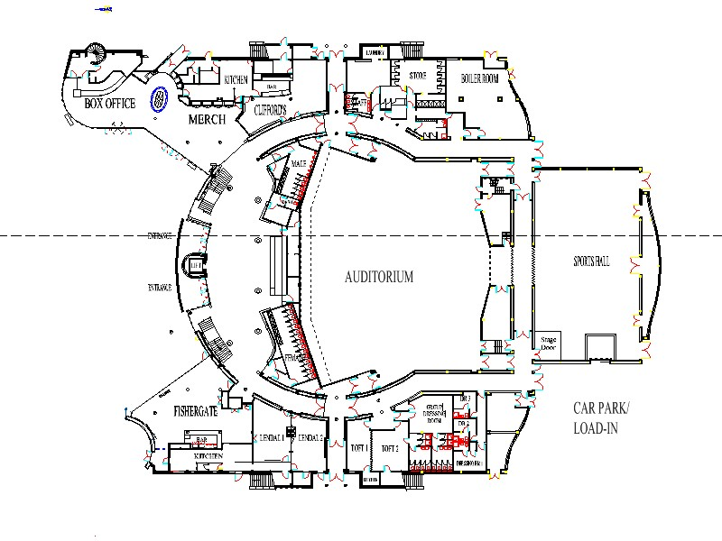

**Further information**

For any further information please contact our Technical Manager, Eric Lund, on 01904 600024 or eric.lund@yorkbarbican.co.uk.