YORK BARBICAN EXHIBITION GUIDELINES

Required Documentation

All exhibitors must provide the event organiser and venue with copies of the following documents:

Risk Assessment
Insurance documents
Method statement
Any other relevant paper work (i.e. if food items are being exhibited we required all health and hygiene certificates)

All paperwork must be specific for the event and be dated accordingly and all insurances must be in date on the date of the event not when booking.

Furniture Available
Occasional chairs
Other furniture available to order

Internet Access
Wireless connections available @ £40+vat per level
Wired connections available @ £40+vat per connection
All internet access must be pre-ordered with the Conference and Events Team

Power
Power can be provided on stands – must be preordered
Please note that all extension leads and adaptors must be provided by exhibitors and any electrical equipment being brought on to the premises for use at the event, must have been recently Portable Appliance Tested (PAT)
RCD’s must be used on all sockets and be provided by the exhibitor or event organiser.
All exhibition stands will be checked for compliance by one of our venue technicians.

Audio Visual
Exhibitors are welcome to bring AV equipment, but must refrain from any activity that might disturb other events or neighbouring buildings. This includes the use of strobe/flash lighting. Audio/visual players must be kept to a reasonable volume. Exhibitors may be asked, at the organiser’s discretion, to adjust the volume where appropriate.

Stand Construction and Materials
All exhibition equipment must be free standing and fit within the agreed stand areas. At no time can anything be affixed to the walls of York Barbican.
Materials used in the construction of all stands must be non flammable or rendered non flammable by recognised treatment. This applies to all fabrics and other dressings used.

Heavy Equipment
If you intend to display any large/heavy pieces of equipment on your stand, please check with the Conference and Events Team in advance to ensure they comply with health and safety regulations of York Barbican.

Storage
York Barbican has very limited storage areas available for use - exhibitors should be advised to ensure all packaging fits behind their stand

GENERAL INFORMATION

Access Timings
Organisers’ access hours will be as agreed and contracted. These timings are to include set up and break down times and additional access hours will be chargeable and subject to availability. Exhibitors’ access times are at the discretion of the organiser, but must be within the hours contracted.

Accessibility
York Barbican is a fully accessible venue. The main entrance is on ground level and there are lifts to all levels. Disabled toilets are available on every floor.

Porter-age
York Barbican is unable to provide porters
There is lift available (133cm length, 109cm width, 230cm tall, 77cm door width) for transporting exhibition equipment between the ground floor and the upper level foyers

Car Parking
There is no on-site car parking at York Barbican. The nearest Car Park is the Q Park located on Kent Street at the rear of the venue (charges apply). There is no on-street parking.

Cloakroom
Cloakroom facilities can be provided if requested in advance with the Conference and Events team. There is no charge for using the cloakroom for private events.

Deliveries/Collections
Due to limited storage space, deliveries and collections can only be made on the day of the event. Please clearly mark all packages for delivery with the name of the event and all exhibitors should additionally mark with either their company name or stand number.
Collections should also be clearly marked with the correct address for delivery.

Fire Evacuation
The fire alarm is never tested when there are clients/delegates/guests at York Barbican and therefore, all instructions to evacuate should be treated as real. York Barbican operates a manned evacuation procedure, whereby our in-house staff will enter your event and direct you to your assembly point via the safest exit.

In the unlikely event, due to unforeseen circumstances, that a team member does not attend to evacuate your event, please find your nearest exit via the lit, green exit signs and make your way outside the building to the main entrance.

Should there be the need to evacuate the building you and your delegates will hear the
following calls:

-in the auditorium:
Red beacons located at the exits will begin to flash. This will indicate our intention to evacuate the building. Our in-house staff will enter the auditorium and direct you out of the building and to the assembly point.

-in all other areas:
The Fire Alarm will sound (loud siren). The in-house staff will enter your event and direct you, via the nearest exit to the assembly point

Conference and event organisers are responsible for head counts for those attending their event

First Aid
There is a Trained First Aider on site at all times

Insurance
All organisers and exhibitors must ensure they have adequate insurance in place to cover the cost of exhibition equipment. York Barbican cannot accept any liability for loss or damage of equipment whilst at the venue. Access to hired spaces is exclusive; however, unless the whole facility has been hired, other areas may still be in use and open for public access. In the event of an accident, York Barbican has Public Liability insurance up to the value of £5 million.

Payphones
York Barbican does not have a payphone. If you require the use of a telephone please speak to one of our on duty stewards.

Smoking/Open Flames
York Barbican is a no smoking venue. At no time may open flames (including candles) or smoke machines be used. Cigarette bins are located outside the main entrance for those who wish to smoke.

Toilets
There are toilets located on all floors of York Barbican

FLOOR PLAN – AUDITORIUM

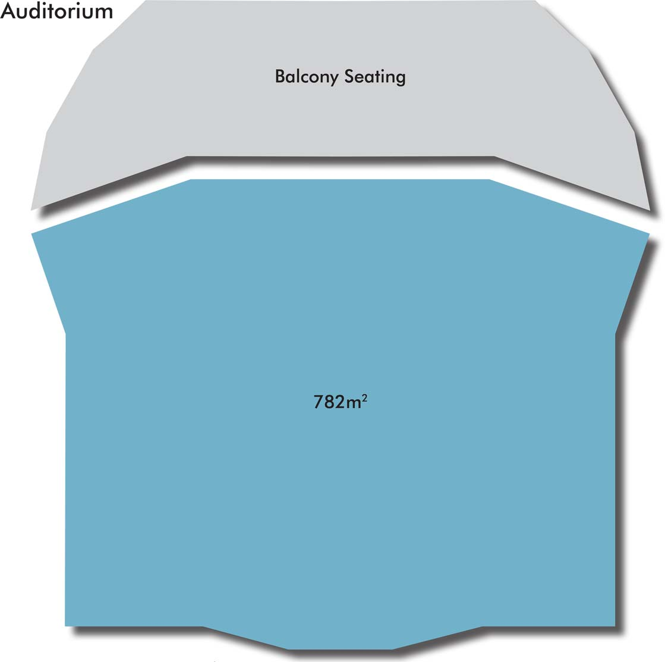

FLOOR PLAN – STALLS FOYER

FLOOR PLAN – BALCONY FOYER

FLOOR PLAN – EXHIBITION HALL

