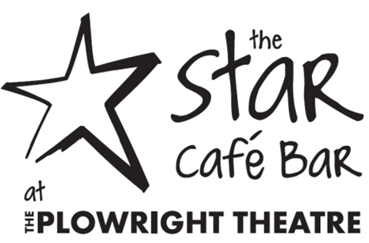

Sandwiches - Served on wholemeal or white bread or tortilla wrap, with salad garnish, chips or curly fries
Prawn with Marie Rose Sauce £3.30
Tuna, Mayonnaise & Cucumber £3.30
Cheddar Cheese & Pickle (v) or Plum Chutney £3.20
Egg Mayonnaise (v) £3.20
Roast Ham & Mustard Pickle £3.30
Chicken Tikka & Salad Leaves £3.30

Served Hot - In Traditional Farmhouse Roll

Bacon. Lettuce, Tomato & Mayonnaise £3.20
Lincolnshire Sausage & Mustard Pickle £3.20
Veggie Burger & Mustard Pickle (v) £3.20

Toasted Sandwiches - Served with Salad Garnish & Homemade Coleslaw

Ham & Cheese £3.20
Cheese & Red Onion £3.20
Cheese & Tomato £3.20
Tuna Melt £3.20

Jacket Potato - Served with Salad Garnish & Homemade Coleslaw

Plain with Butter £2.80
Cheddar Cheese £3.30
Prawns with Marie Rose £4.00
Tuna & Mayonnaise £4.00
Baked Beans £3.30
Chilli Con Carne £4.10
Coleslaw £3.30

**Meal Deal to Take Away**
Hot or Cold Sandwich of your choice, Crisps & Drink - £4.60

Soup
Soup of the Day with Bread Roll & Butter £2.90
Soup & Sandwich Combo £4.40

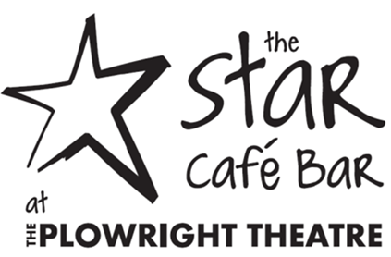

Main Meals – Served with a choice of Chipped Potatoes Jacket Potato or Salad
Ham & Cheese Omelette £4.90
Fish, Chips & Mushy Peas or Garden Peas £5.50
Chunky Chicken Bites with Sweet Chilli Dip £4.90
Chilli Con Carne with Rice or Chips £4.90

See Board for Tasty Daily Specials

Side Orders

Portion of Chips £1.80
Portion of Spicy Spiral Fries £2.00

Children’s Menu

Fish fingers, Chips or Jacket Potato & Beans £2.60
Chicken Dinosaur with chips & beans or mixed vegetables £2.60
Sandwich box with Egg or Ham Sandwich, Crisps, Carton of Juice, with Colouring Book & Crayon
£2.60

Sweet Treats
Variety of Cakes £1.50
Flap Jack £1.10
Giant Scone with Butter & Jam £1.50
Apple & Blackberry Crumble & Custard £3.00

Hot Drinks
Pot of Tea for One £1.30
Cup of Tea £1.20
Black coffee £1.50
Mochaccino/Cappuccino £1.70
Decaffeinated Coffee £1.50
Hot Chocolate £1.70
Or Select a cold drink from the licensed bar

Take Away
All of our menu is available to take away
Just ask a member of staff

